CURRICULUM VITAE
of

Faculty of Medicine

Benha University

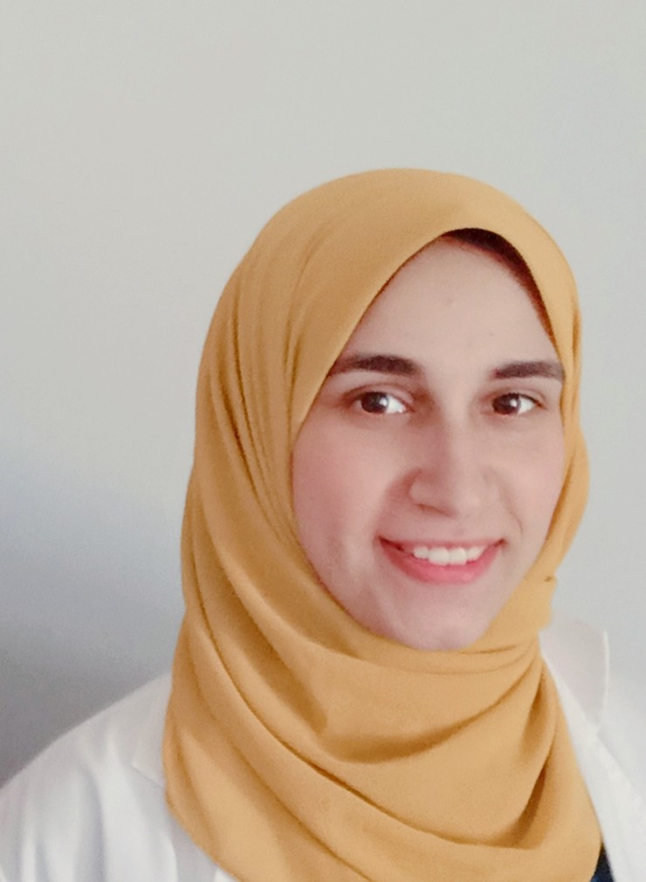

Personal photo

Personal Data
Name (Arabic) | اميرة محمد سمير محمد حسين
Name (English) | Amira mohammed Samir mohammed
Department | Forensic medicine and clinical toxicology
College | Faculty of medicine benha university
Academic degree | demonstrator
Mobile | 01096241323
Home phone | 0132584981
work phone | 01096241323
Email (university) | a.hussein55818@fmed.bu.edu.eg
Alternative E mail | Amra.samir9592@gmail.com
Web site | Amira Samir

Education
Institution | Degrees obtained | Year
Benha University | Bachelor of medicine and general surgery | 2020
Benha University
Benha University

General specialty | Bachelor of medicine and general surgery
Specific specialty | Forensic medicine and clinical toxicology

Language
Language | Reading | Speaking | Writing
Arabic | Excellent | Excellent | Excellent
English | Excellent | Excellent | Excellent

Membership of Professional Bodies (List)

Interesting Areas of Research

MSc Supervision
Title | Year completed / in  Progress

PhD Supervision
Title | Year completed / in progress

Positions
Date From - to |  | Organization | Country | Position | Role
1 | From2022 till present | Faculty of medicine benha university | Egypt | Demonstrator | Teaching
2
3
4
5

Attended Workshops, Symposiums, and Conference
Name of Workshops, Symposiums, and Conferences | Year
The annual coference of benha university | 2023

- Training and Clinical Experience:
a- resident at benha university hospital
b-

- Skills:

b.

- List of publications:

  - 0

